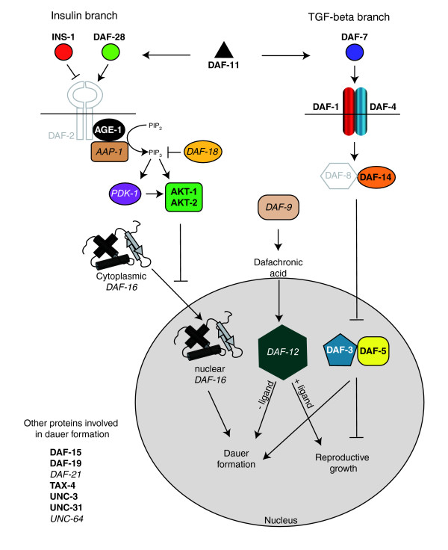

A majority of dauer pathway genes are enriched in either the larval pan-neural (LP) or embryonic pan-neural (EP) datasets. Two neuronal pathways influence the decision to dauer, an alternative developmental pathway adopted in unfavorable conditions [49-54]. During normal growth, the DAF-28 insulin-like molecule activates the DAF-2 insulin receptor to initiate a signal transduction pathway that prevents the translocation of the DAF-16 Forkhead transcription factor into the nucleus, thus blocking dauer formation. In a parallel pathway, DAF-7/TGF-beta activates receptors DAF-1 and DAF-4 to inhibit the Smad/Sno complex DAF-3/DAF-5, thereby promoting reproductive growth. The guanylyl cyclase DAF-11 drives expression of DAF-28 and DAF-7. During reproductive growth, the CYP2 cytochrome P450 enzyme DAF-9 is active and produces the DAF-12 ligand dafachronic acid. In the presence of its ligand, the nuclear hormone receptor DAF-12 promotes normal development. In the absence of its ligand, DAF-12 instead promotes dauer formation. Other proteins function independently of these pathways (for example, the DAF-19 transcription factor specifies ciliated neurons that detect exogenous dauer-inducing signals). Bold lettering denotes enriched transcripts and italics marks EGs detected in at least one of the pan-neural datasets. Gray letters refer to transcripts not found in either EP or LP datasets. See Additional data file 18 for a complete description of these genes.

Figure from S. von Stetina et al. (http://genomebiology.com/2007/8/7/R135)